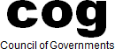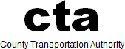

DARK IN JULY NOTICE

Mountain/Desert Policy Committee July 19, 2024
9:30 a.m.

LOCATION:
Mojave Desert Air Quality Management District 14306 Park Avenue, Victorville, CA 92392

The July 19, 2024, meeting of the Mountain/Desert Policy Committee will go Dark in July. The next regularly scheduled meeting will be held on Friday, August 16, 2024 at 9:30 a.m. An agenda will be posted on the SBCTA website prior to the meeting.

